The SCWLA Foundation is pleased to announce the 2015 recipients of the SCWLA FOUNDATION SCHOLARSHIPS: JULIA SPITLER OF THE UNIVERSITY OF SOUTH CAROLINA SCHOOL OF LAW and MORGAN IVEY OF THE CHARLESTON SCHOOL OF LAW.

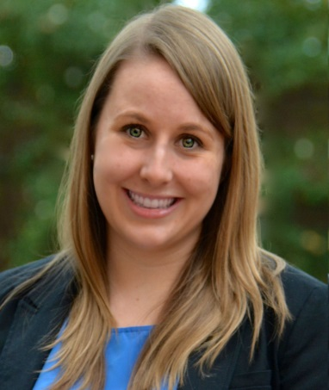
Last summer, Julia created a volunteer advocate program for Sexual Trauma Services of the Midlands and Sistercare to aid victims of sexual assault and abuse through the legal process. She has also served as Secretary and now President of Women in Law. Julia has been described as “an impassioned and educated advocate” for women’s issues and hopes to use her law degree to work with vulnerable populations, such as children or elders.

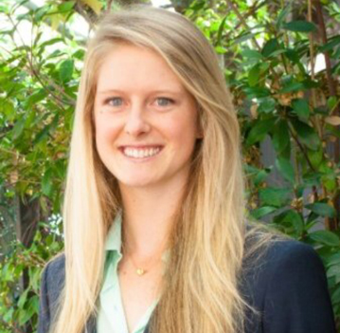
Morgan is President of Women in Law and has organized numerous events to build bridges between women law students and women lawyers practicing in Charleston. She also organized several successful fundraisers including a silent auction benefiting The Point, which supports low income women, and the “Miss” Charleston Law Pageant, a peer support fundraiser.

Please join us in congratulating these wonderful women and encouraging them in their studies and anticipated contributions to the South Carolina legal community.

